

COMMERCIAL PROPERTY

FOR SALE

WATERWORKS, WESTMORELAND

Submission Deadline: 11:00 a.m. on Monday, May 13, 2024

Table of Contents

Submission Checklist……………………………………………………….………………… 3

Invitation to Bid …………………………………….……….………………………………….4

Property Information Overview ………………………………………….…………….……….5

Property Comparison Guide ……………………………………………………………………9

Evaluation and Qualification Criteria ………………………………………………...……….10

Bidding Forms ………………………………………………………………………………...13

SUBMISSION CHECKLIST

The following documents must be submitted with the bid:

**(Bidders are encouraged to use this checklist to ensure that all the required documents are submitted with thebid.)**

|  |  |
| --- | --- |
|  | *Tick Box (√)* |
| * Completed and signed Commercial Property Bid Form |  |
| * Statement or letter from financial institution, NOT OLDER THAN SIX MONTHS, stating the:   + Proposer’s name   + Currency of the funds   + Account balance: **Please Note that the account balance must be able to cover the following:**     - Required deposit - (the minimum deposit is 15% of the purchase price proposed)     - Related costs - (estimated at 3% of the proposed price     - Balance on the Sale Price   If any portion of the bid amount will be covered by a mortgage. please submit:   * THE ORIGINAL: Mortgage pre-approval letter from a financial institution NOT OLDER THAN SIX MONTHS |  |
|  |  |
|  |  |
|  |  |
|  |  |
|  |  |
|  |  |
|  |  |
|  |  |

# INVITATION TO BID

# SALE OF COMMERCIAL PROPERTY

# WATERWORKS - WESTMORELAND

The National Housing Trust (NHT) invites interested persons to submit bids to purchase commercial lots, at Orange Street, Waterworks Housing Development, Westmoreland.

Waterworks Housing Development runs along the Ferris Cross to Mackfield main road. The development is approximately 10 kilometers from Savanna-la-mar.

* Lot #1 - approximately – 4,506.824 sq. m (43,668 sq. ft.) – reserved for commercial activity
* Lot#100 - approximately – 864.45 sq. m (9,305 sq. ft.) – reserved for commercial use

**BID DOCUMENTS:**

Bid documents will be available as at February 19, 2024, at www.nht.gov.jm. Copies may also be requested by emailing [properties@nht.gov.jm](mailto:properties@nht.gov.jm).

**SUBMISSION & OPENING OF BIDS:**

Sealed bids, clearly stating the property of interest, the bidder’s name and contact number should be deposited in the box marked “COMMERCIAL PROPERTY FOR SALE: WATERWORKS, WESTMORELAND” no later than 11:00 am on Monday, May 13, 2024.

There will be a public opening of bids at 10:00 am on **THURSDAY MAY 16, 2024** in the Information Systems meeting room, NHT Head Office, 4 Park Boulevard, Kingston 5 at the time indicated below, for each development.

|  |
| --- |
| **BIDS MAY BE DEPOSITED IN THE APPROPRIATELY LABELLED BOX, AT**  NHT Head office  4 Park Blvd,  Kingston  **OR**  Westmoreland Branch Office  123 Great George Street, Savanna-La-Mar |

**The NHT reserves the right to reject any/ all applications and *NHT reserves the right not to award a contract to any party with whom it is currently in litigation or with whom it has been previously involved in litigation*.**

***For further information, please contact:***

**Advertising, Marketing & After Sales**

**National Housing Trust**

**1-888-CALL-NHT**

**(2255-648)**

**www.nht.gov.jm**

**4 Park Boulevard, Kingston 5**

**Tel: 876-929-6500-9, Ext. 7271**

PROPERTY OVERVIEW

The Waterworks Housing Development in the parish of Westmoreland was developed in 2006 comprising units and serviced lots and two lots earmarked for commercial activity. The development is approximately 10 kilometers from the parish capital of Savanna-la-mar.

The area benefits from a range of urban services and facilities including mains water, electricity, cable television, telephone services, fire and police protection, garbage collection/disposal, churches, schools and neighbourhood shops. The nearby communities such as Whithorn and Haddo provide limited shopping facilities whilst higher order goods and services inclusive of financial institutions, market, hospital, post office and other government services are available in Savanna-la-mar – the parish capital, which is approximately 10 kilometres (6.2 miles) away.

The properties, which is designated for commercial use, is part of and is on the periphery of a residential housing scheme that was conceptualized through the combined efforts of the Ministry of Housing and the National Housing Trust around 2010. The overall development currently exhibits a well built-up estate with single and two-storey residences, the majority displaying diverse architectural designs and are of standards that contribute to the improved status of the community

**Market Profile**

With increase and improvement in the number and quality of the services and facilities being offered in the area, Waterworks and its environs will eventually become a well serviced neighbourhood. The potential for further commercial expansion in the area should also improve in tandem with new residential ventures/developments and should benefit from the existing infrastructure and the precedence of commercial approval as set by the planning authority. The subject property is located along a main road, which gives it good exposure to the commuting public and being at the entrance of a modern housing development, the enterprises on this property should enjoy at least moderate patronage from residents when the land is developed.

There are two (2) commercial parcel at Water Works, Westmoreland which are available for divestment. The commercial Lots in Water Works are situated on the Ferris main road from Savanna-la-mar to Montego Bay. Both Lots are bordered on the main road on either side of the entrance to the Water Works housing development. The main road is well paved while the road to the scheme is in need of repairs.

These are as follows:

|  |  |  |
| --- | --- | --- |
| Lot # | Details | Zoning |
| Lot #1 | Vol. 1437 / Folio 607  approximately – 4,506.824 sq. m (43,668 sq. ft.) | Commercial |
| Lot #100 | Vol. 1437 / Folio 717  approximately – 864.45 sq. m (9,305 sq. ft.) | Commercial |

Lot #1 – Vol. 1437 / Folio 607

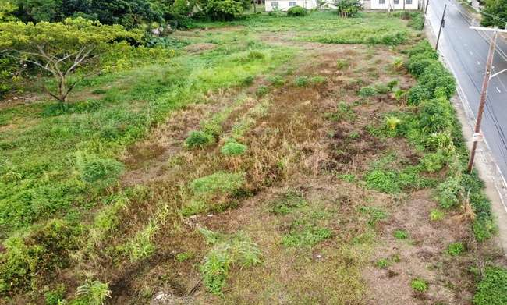

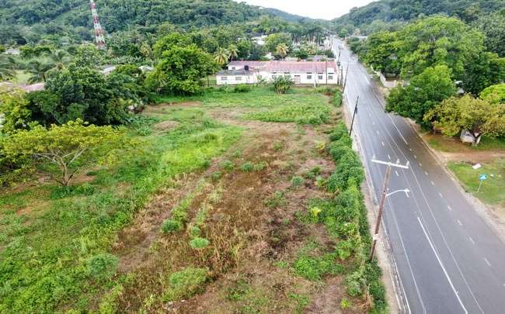

Property along the Waterworks main access road

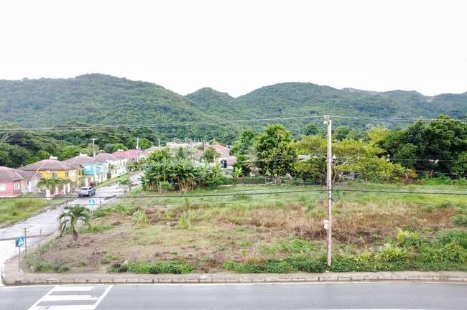

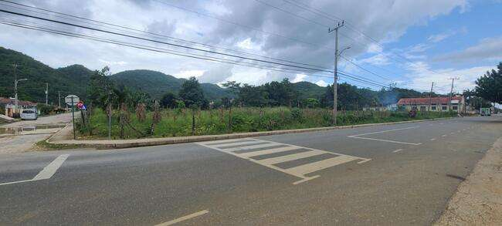Property is bordered by Orange Street, which is the main road taking you to the Waterworks Housing Development

The site has a rectangular shape with triple road frontages. It is situated at road grade with a gentle slope giving the appearance to be free draining at the surface.

Lot #100 – Vol. 1437 / Folio 717

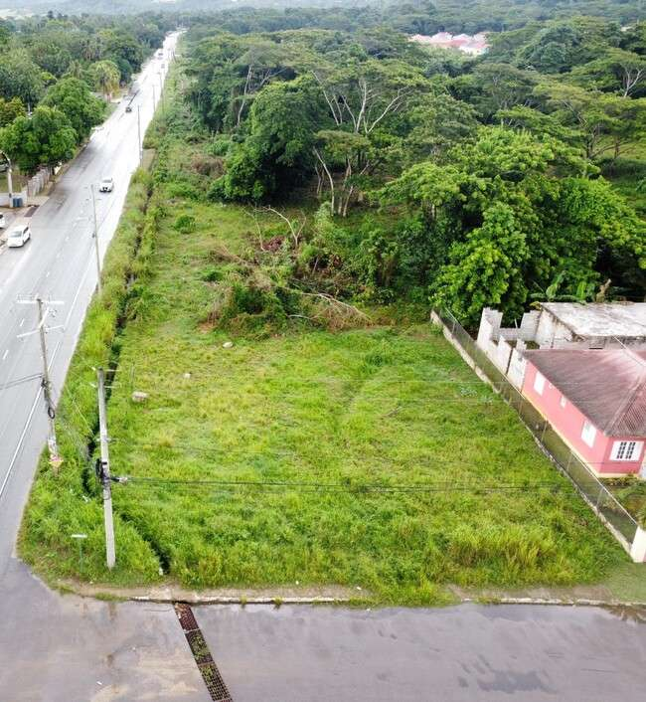

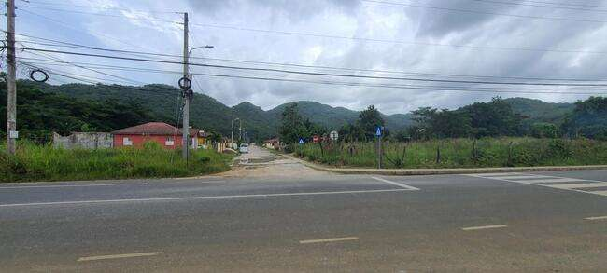Property is bordered by Orange Street, which is the main road taking you to the Waterworks Housing Development

The site has a regular shape with double (corner) road frontage.

PROPERTY COMPARISON GUIDE

The following sales comparison within the Westmoreland and Hanover regions for properties sold recently can be used as a guide to help in arriving at a bid amount.

|  |  |  |  |
| --- | --- | --- | --- |
|  | Industry Cove, Green Island, Hanover | Paradise Pen, Westmoreland | Paradise Pen, Westmoreland |
| Reference | 1437/ 669 | 1572/369 | 1572/370 |
| Year of Sale | 2022 | 2023 | 2023 |
| Land size | 5,489 m2 | 1,877 m2 | 1,060 m2 |
| Sale Amount | $26.65M | $18M | $15M |
| Zoning | Commercial | Commercial | Commercial |

Evaluation and

Qualification Criteria

EVALUATION AND QUALIFICATION

|  |
| --- |
| Eligibility   1. Bids relating to the Sale of Commercial Property/ Lots/ Units shall be accepted from employed, self-employed and entities that operating in Jamaica. |
| Qualification   1. Duly completed Commercial Property Bid Letter with required documents    1. statement or letter from financial institution, NOT OLDER THAN SIX MONTHS, stating the:       1. Proposer’s name       2. Currency of the funds       3. Account balance   **Please Note that the account balance must be able to cover the following:**   * Required deposit - (the minimum deposit is 15% of the purchase price proposed) * Related costs - (estimated at 3% of the proposed price) * Balance on the Sale Price.   Note:  Bidders will have to meet the qualification requirements as set out for a financial assessment of their bid to be considered. |
| Financial   1. All bids must be I Jamaican Dollars 2. Highest bid price for the property. 3. Earliest bid received where a tie breaker is needed. |

Award Criteria

1. Bids must have met the eligibility and qualification requirements
2. A bid can be submitted for more than one Lot. Please note that a Bid Letter MUST be completed for each Lot to which a bid is being submitted.
3. Bids received will be ranked by amount and the order in which they are received.
4. Any Bidder that has submitted the highest bid for more than one Lot will have the right of first refusal for any of these Lots.
5. Following the right of first refusal, the next ranked bidder will be offered the one
6. A bidder that has submitted the highest bid for a Lot may reject the award and withdraw their bid. Such bidder would not be eligible for award of any other Lot that was advertised.
7. The ranked bids will be evaluated until all the Lots have been awards
8. In addition to being the highest bid submitted for the property, this bid MUST be within a margin of 15% of the Market Reserved Price for it to be considered. The Market Reserved Price shall be determined by averaging the market value of the property as given by two independent Chartered Valuation Surveyors.
9. Earliest bid received where a tie breaker is needed will be considered as the preferred bid.
10. The NHT reserves the right to reject any/ all applications

Bidding

Forms

**INSTRUCTIONS**

|  |
| --- |
| * **This form should be used to submit a bid (an offer to purchase) for a Commercial Property being sold by the NHT.** * **COMPLETE FORM IN BLOCK LETTERS. (N.B. Please initial any change made to the completed form)** |

|  |
| --- |
| **YOUR BID WILL BE DISQUALIFIED IF YOU DO NOT COMPLY WITH THESE INSTRUCTIONS** |

|  |
| --- |
| PLEASE SUBMIT THE FOLLOWING DOCUMENTS WITH THIS COMPLETED ORIGINAL bid  LETTER   1. Statement or letter from financial institution, NOT OLDER THAN SIX MONTHS, stating the:    * Proposer’s name    * Currency of the funds    * Account balance   **Please Note that the account balance must be able to cover the following:**   * Required deposit - (the minimum deposit is 15% of the purchase price proposed) * Related costs - (estimated at 3% of the proposed price) * Balance on the Sale Price.   If any portion of the bid amount will be covered by a mortgage. please submit:   1. THE ORIGINAL: Mortgage pre-approval letter from a financial institution NOT OLDER THAN SIX MONTHS |
| **NOTE: The following persons are not allowed to bid for Commercial property sold by the NHT:**   * NHT staff members, their spouses or extended family members of NHT staff * NHT Board members, their spouses or extended family members of the NHT Board * Staff of contracted external agencies, their spouses and extended family |

**COMMERCIAL PROPERTY BID FORM**

**COMPLETE FORM IN BLOCK LETTERS. (N.B. Please initial any change made to the completed form).**

Date__________________ BIDDERS INFORMATION

|  |  |
| --- | --- |
| 1. Bidder’s name and mailing address |  |
| 1. Bidder’s current legal status (e.g., corporation, limited liability company, partnership, or sole-proprietorship/ self-employed) |  |
| 1. Bidders Taxpayer Registration Number (TRN) |  |
| 1. If Bidder is a corporation, limited liability company or partnership:  * Contact person’s name * Title * Telephone number * e-mail address * Copy of a valid Certificate of Incorporation of the company OR Certificate of Registration for partnership |  |
| 1. Signature of Bidder (if Bidder is an entity, the signature and title of the individual authorized to sign on such entity’s behalf). |  |
| Please provide complete answer to all questions below by placing a tick in the appropriate box. | |
| 1. Are you a member of staff of the NHT or related to any member of staff of the NHT?   [ ] YES [ ] NO | |
| 1. Are you a member of staff of NHT’s contracted External Agencies or related to any member of staff of NHT’s contracted External Agencies?   [ ] YES [ ] NO | |
| 1. The purchase will be financed by   [ ]- Mortgage – Other financial institution  [ ] - Cash or Other source | |
| 1. Enclosed please find   [ ] - Pre approval letter from financial institution if purchase is being financed by a mortgage  [ ] - Documentary evidence of availability of funds | |

Selection Committee

National Housing Trust

4 Park Boulevard,

Kingston 5

Dear Sirs:

I/We_____________________________________ and _______________________________________

*[Name of Proposer (A)]*   *[Name of Proposer (B)]*

hereby submit a bid for property located at: __________________________________________________

_____________________________________________________________________________________

*(Full Property Address as advertised)*

in an amount of ________________________________________________________________________

*(Bid amount in words)*

(J_________________________________________________________________________________)

*(Bid amount in figures)*

I/We may be contacted at

___________________________________ _________________________________________________

*[Mailing Address of Bidder (A)]*

_____________________________________________________________________________________

*[Mailing Address of Bidder (B)]*

Telephone number________________________ (H) Telephone number_______________________(H)

_________________(W)___________________(C) _______________(W)__________________(C)

TRN____________________________________ TRN: ____________________________________

Email: ___________________________________ Email: ___________________________________

_________________________________________ ________________________________________

*Signature of Bidder (A) Signature of Bidder (B)*